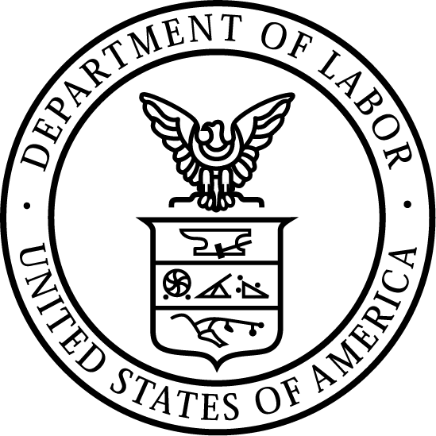
News Release
U.S. Department of Labor | April 6, 2020

U.S. Department of Labor Publishes New OSHA Poster
Aimed At Reducing Workplace Exposure to the Coronavirus

WASHINGTON, DC – The U.S. Department of Labor’s Occupational Safety and Health Administration (OSHA) has issued a new poster listing steps all workplaces can take to reduce the risk of exposure to coronavirus.

The poster highlights 10 infection prevention measures every employer can implement to protect workers’ safety and health during the coronavirus pandemic. Safety measures include encouraging sick workers to stay home; establishing flexible worksites and staggered work shifts; discouraging workers from using other workers’ phones, desks and other work equipment; and using Environmental Protection Agency-approved cleaning chemicals with label claims against the coronavirus.

The new poster is available for download in English, or Spanish.

Visit OSHA’s Publications webpage for other useful workplace safety information.

The release is the latest effort by OSHA to educate and protect America’s workers and employers during the coronavirus pandemic. In response to President Trump’s action to increase the availability of general use respirators, OSHA has issued a series of guidances that expand access to respirators in the workplace. OSHA has also published Preparing Workplaces for COVID-19, a guidance aimed at helping workers and employers learn about ways to protect themselves and their workplaces during the ongoing pandemic.

Visit OSHA’s coronavirus webpage frequently for updates. For further information about coronavirus, please visit the U.S. Department of Health and Human Services’ Centers for Disease Control and Prevention.

Under the Occupational Safety and Health Act of 1970, employers are responsible for providing safe and healthful workplaces for their employees. OSHA’s role is to help ensure these conditions for America’s working men and women by setting and enforcing standards, and providing training, education and assistance. For more information, visit www.osha.gov.

The mission of the Department of Labor is to foster, promote and develop the welfare of the wage earners, job seekers and retirees of the United States; improve working conditions; advance opportunities for profitable employment; and assure work-related benefits and rights.
# # #
Media Contact:
Emily Weeks, 202-693-4681, weeks.emily.c@dol.gov

Release Number: 20-581-NAT

